# CS5551 - Adv Software Engineering – Lab 2 Report

**Home Page –** Search for City and State **–** Two input fields

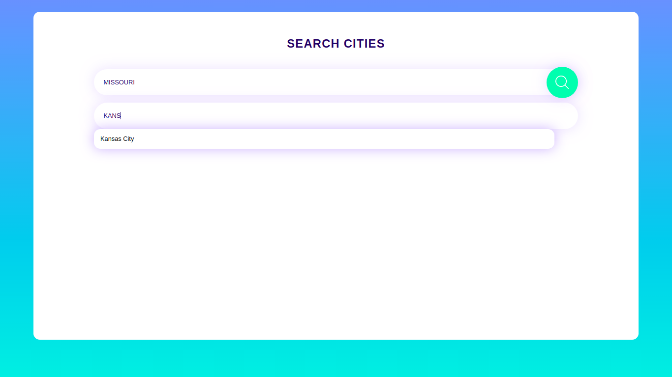

**Weather Forecast -** temperature, wind, humidity, status with hourly report.

